A.P. Lit & Comp/Dual Enrollment Summer Reading Assignment 2020

Parts I and II: Everything should be typed, printed, and brought on the first day of school.
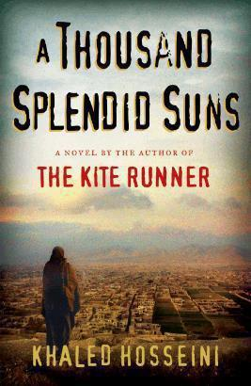

Part I: Read A Thousand Splendid Suns (ATSS) by Khaled Hosseini

Complete a major works data sheet (MWDS) and be prepared to take an assessment during the first week of school. The Major Works Data Sheet may be found on the webpages of Mrs. Garrett, Mrs. Towey, and Mrs. Fulton. The writing on this document should be your own work and will be submitted to Turnitin.com during the first week of school. (Note: You cannot upload to Turnitin until you have joined the class, which will be after school starts.)

Part II: Personal Writing – Choose ONE of the following topics. Think about the characters in ATSS and compare to people in your life. Write a short (300 word) essay.

- In ATSS, there were many types of families, both good and bad. Some families in the book are single mother/child, traditional mother/father/child, polygamy, dysfunctional, blended. Discuss what makes a good family, in your opinion and experiences.

- What makes a good mother, in your opinion? Give examples from your own life. You might discuss the mothers -- Nana, Laila, Fariba -- and how Mariam learns to mother in the novel.

- What makes a good father, in your opinion and experience? Evaluate Rasheed, Jalil and Babi as fathers. How does their culture affect their parenting?

